

|  |  |
| --- | --- |
| Name | Reg No |
| Azan shoaib | Fa19-bse-107 |
| Daniyal khattak | Fa19-bse-117 |

**P-H Web**

**Description:**

PH_Web will allow both the customers and seller to upload, discover, like, and discuss about different products. It will include a voting system and a comment system about a product based on which the products get ranking by their popularity and positive reviews. For this purpose, Upvotes technique from fellow community members will be used. More specifically, if a customer likes the product, it Upvotes it. Based on the number of Upvotes, a product is ranked higher in our PH_Web.There wil be a comment section on each product for the member to share his point of view about the specific product.The Top ranked product of the month will get a badge or reward on this website and that specific product will be shown on the top of the product section until the next ranking.Our website will also provide an option to the users of this website to share their point of view about any improvement or any change or update in our system that they want.

**Background:**

There is no such website existing in Pakistan. We have made it for the first time in Pakistan. On this site the hunters can launch their products and other users can find the latest ranked and the best product they want.

**Product Prespective:**

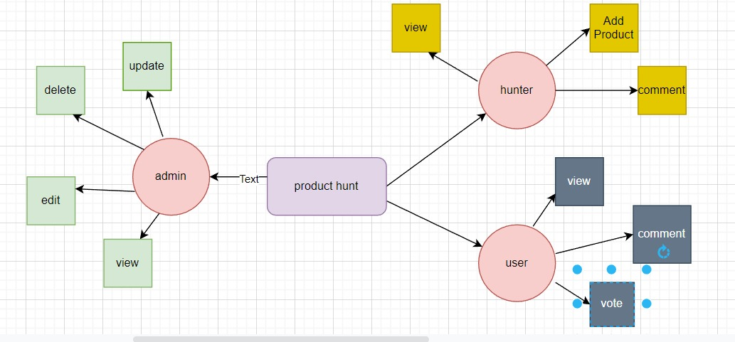

**Scope:**

In recent years, the people have been using the e-commerce platforms, like Amazon, Daraz.PK, Olx, very frequently to sale and/or buy different items. The sellers use different platforms for marketing like advertising one Facebook, Youtube, etc. Similarly, the customers have to search these different platforms for the new products, the quality of the products through the customers review. In this regard, there has been an effort to provide a single platform, like https://www.producthunt.com/, where the sellers can advertise a product, and the customers can get the information/availability of a product by different companies and the customers' review. In Pakistan, this idea still needs more exposure. Our project, named PH_Web, aims to develop such a web platform for the local companies of Pakistan.

**Users and charactristics:**

* **User module:**

Everyone who will sign up on this platform is the member of our platform.They can only check the product and can comment or vote that product.

* **Hunters:**

Hunters are the owners of the product who are here for the marketing of their product.They can launch their product on our website.

* **Admin:**

Admin is allowed to control and maintain the whole website.admin can view,edit,delete,update any information in the website.

**Requirements:**

* **Functional Requirements:**

 • User Signup with secure authentication • Create and display products • View user profile pages • Discussion board allowing top level comments and reply’s • Searching for products • Upvoting of products and comments. • Settings • Blogs • Add and display Deals for companies. • Badges and Award Modules used in our FYP project are provided as follows: • User Signup with secure authentication • Create and display products • View user profile pages • Discussion board allowing top level comments and reply’s • Searching for products • Upvoting of products and comments.Modules used in our FYP project are provided as follows: • Settings • Blogs • Add and display Deals for companies. • Badges and Award.

* **Non Functional Requirement:**
* The system should notify about the login failure and prevent user from login into the system if that user tries to login with a non existing account.
* The system should ask the user to choose a different user name is the user want to create an account and the desired username is already occupied.
* The user should be connected to the internet to use our website.